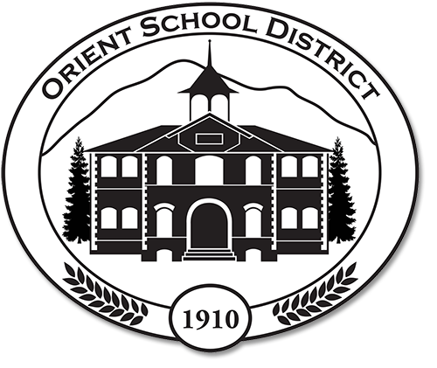

Academic and Student Well-Being Recovery Plan
2021-2022

The Orient School District used the Orient School District Equity Planning Tool as developed by the Equity Analysis Team to guide the development of our Academic and Student Well-Being Recovery Plan. This tool is an adaptation of the Arts Corps 2014 and Seattle Race and Social Justice Initiative of August 2012 and may be found on the Orient Schools website at www.orientsd.org. Based upon the analysis of the student population using this tool, the following groups have been identified as needing strategic supports: white students, students of more than one race, low income students and students with disabilities. This student population groups call for the blending of both strategic and universal supports across the student population served.

The Orient School also surveyed all Orient School families in May of 2021 using a district-generated survey entitled The Orient School Academic and Student Well-Being Recovery Plan Survey. Based upon these survey results, the Orient School administrative team has determined the following universal supports will be made available for all students in the 2021-2022 school year to recapture lost learning:

- Additional instructional time will be allocated before and after school for individuals in need of further support;
- Use of inclusionary practices to support all students with disabilities;
- Continuation of multi-tiered supports for learning;
- Strategic staffing, including reduced grade-band configurations;
- Continual and responsive surveying of student voice and perceptions.

In addition, the school will be taking half days every Friday during the 2021-2022 school year to both analyze data derived from testing as established below and to undertake professional development in areas proven to support student learning. These areas include, but are not limited to:
- Relationship-building between staff and students;
- Literacy in early learning (K-4) will be undertaken;
- Equitable grading practices;
- SEL and Mental Health Supports;
- Inclusionary practices;
- Project-based learning.

Lastly, the Orient School will be utilizing financial and personnel resources to support learning using the following:
- High-quality tutoring;
- Transitional supports to support pre-K to elementary and Middle School to high school

All of these actions will be evaluated for efficacy on an on-going basis. This will include the following diagnostic assessments and grade levels:
*Accelerated Reader (1st-8th), *Curriculum assessments (K-8th), *Dibels (K-8th), GOLD WaKIDS (K),* iReady (K-8th), OSPI Dyslexia screeners (K-2), Smarter Balanced (3rd-8th),
*STAR Reading (1st-8th), and * In-house assessments (K-8th).

*Diagnostic given multiple times a year. If not starred, diagnostic is given annually.

It is of note that not only has our students’ academic growth been impacted, their emotional growth has also been altered. To address this, our staff will be administering two diagnostics, the *Panorama Education School Climate Survey and WA-KIDS.

*Diagnostic given multiple times a year. If not starred, diagnostic is given annually.

Student progress in both academics and emotional growth will be monitored on an on-going basis. The staff will be meeting quarterly to delve into data derived from the above stated diagnostics and view these results through the Orient School Equity Analysis Tool. We will use this information to monitor progress, adjust our strategies and identify any nerw student learning gaps that may arise.

